Birla Institute of Technology & Science, Pilani
Work Integrated Learning Programmes Division
Second Semester 2023-2024

Mid-Semester Test
(EC-2 Makeup – ANSWER KEY)

Course No. : DSECL ZC556
Course Title : Stream Processing and Analytics
Nature of Exam : Open Book
Weightage : 30%
No. of Pages = 4

No. of Questions = 5
Duration : 2 Hours
Date of Exam : 06/03/2021 or 19/03/2021 (FN/AN)
Note to Students:
- Please follow all the Instructions to Candidates given on the cover page of the answer book.
- All parts of a question should be answered consecutively. Each answer should start from a fresh page.
- Assumptions made if any, should be stated clearly at the beginning of your answer.

Q1. Answer the following in brief: [2 * 3 marks = 6]
- Can Kafka be used to implement a traditional RDBMS replication system? Justify.
Answer:
Yes, Kafka can be used to implement a traditional RDBMS replication system. To do this, changes to the table in source database would be written to Kafka using normal producer protocol. The target database itself would be a consumer of the Kafka data and applies changes made to the tables by reading from the Kafka.
- How Flume ensures that messages are not lost when they are in transit?
Answer:
There are two channels which can be used by Flume to ensure that messages are not lost when they are in transit, namely
- File channel
- JDBC channel

- Explain two common types of data processing patterns.
Answer:
Two common types of data processing patterns are:
- Batch processing: processes data at regular intervals, assumes high response times
- Stream processing: processes data immediately, meant for low latency requirements
Q2 Assume that you are working on a Real Estate app that allows the users to Search New Projects, Homes, Apartments, Offices, Shops, and Showrooms for Buy, Sell, and Rent. This property app is required for all fulfilling all the real estate needs for searching, shortlisting and finalizing property of their choice. Be it a ready-to-move flat in a new project, investment in shops, offices or showrooms, or girls PG or boys PG in city, app should have listings from qualified property agents & top builders as well as no brokerage properties. This house search app should make property search on mobile simpler, faster and smoother. Search for residential and commercial property listings from owners, brokers and top builders on this user-friendly app that should help millions of users to start their real estate journey. To make it more interesting and meaningful, when the users are online searching for a property on the app, the recommendations about the relevant properties should be shown to her. Also relevant advertisements has to be shown on the app screen to increase the chances of converting these paid advertisements into increasing the foot falling and result into actual selling. [2 + 1 + 1 + 2 = 6]
- What would be the impact to this online property business if the communication between the collection tier and analysis tier were interrupted for an extended period of time?
- How many days’ worth of data can this online property business tolerate losing?
- Would you anticipate that online property business need to store historical data?
- What type of message delivery semantics does this streaming systems need?
Answer:
- Not being able to have marketing opportunities to upsell and cross-sell would cause this feature to not function. No product recommendations would be made. It would be hard to quantify the monetary value for this business, but for sure it would be lost opportunity and lost sales.
- Perhaps we could provide an old-fashioned batch-recommendation system as a backup, but the freshness of the data may be an issue.
- Perhaps for reporting purposed and for refinement of any algorithms that can be developed.
- Having at least once should suffice for this case. Exactly-one is overkill.

Q3. Consider the following Kafka’s cluster architecture while answering the following sub-questions.
[1 + 2 + 1 + 1 + 2 + 1 = 8]
Cluster Description:
- 3 node cluster
- Name of the Topic: Twitter
- Number of Partitions: 3
- The Replication factor of ‘Twitter’: 3
- 3 producers
- 3 consumers

- How many number of Kafka brokers can be present in this system? [1]
Answer:
Ideally three on three different nodes, but it can be any number as multiple brokers can be started on a single machine as well (not recommended for production systems)
- A producer “A” wants to write to “Twitter” partition 2. Is that possible? Justify. [2]
Answer:
No, it’s not directly possible. Producer “A” can specify the same key along with the message to the written to the Kafka topics, then Kafka system will add messages with same keys to the same partition (but the partition to which messages will be written will be determined by Kafka only, user will not have any control over it).
- If the number of consumers for the same consumer group is raised to 4, how will be the load distributed across these consumers? [1]
Answer:
When we increase the number of consumers to 4, one of these four consumers will sit idle unless another consumer fails and the Kafka cluster performs rebalancing.
d. How many consumer groups can be created for this configuration? [1]
Answer:
There can be an indefinite number of consumer groups working simultaneously.
e. Can we have multiple brokers on the same machine? Would having multiple brokers solve the problem of data loss in the case of machine failure? [2]
Answer:
Yes, it is possible to have multiple Kafka brokers on the same machine. However, having multiple brokers would not ensure fault tolerance in case of server/machine failure. [1]
f. A producer “A” writes keyed messages to the Kafka topics. If we increase the number of partitions to 4, whether it will impact the parallelism? Justify.
Answer:
No, it will not impact the parallelism of consumers as the keyed messages will be still written to the existing partitions of the Kafka topic.

Q4. Explain at appropriate length and with adequate reasoning, why it will be very difficult to support “exactly-once” message delivery semantics with message queuing system. [5]
Answer:
A broker with message queue
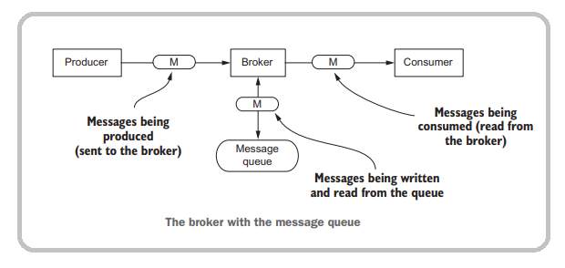

Such a system comes with caveats and risks. Figure shows possible points of failure. It seems as if almost every spot in the diagram is a possible point of failure.
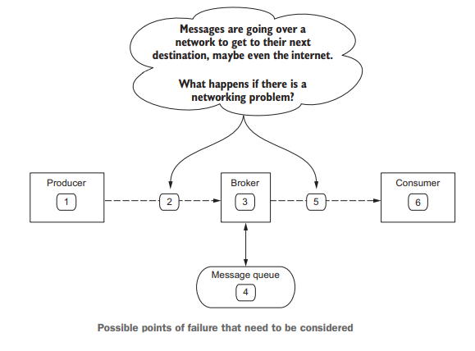

- 1 Producer—if the producer fails after generating a message but before sending it over the network to the broker, we will lose a message. There is also a chance that the producer may fail waiting to hear back from the broker that it did receive the message, and the producer after it recovers may send the same message a second time.
- 2 The network between the producer and broker—if the network between the producer and the broker fails, the producer may send the message, but the broker never receives it or the broker does receive it but the producer never gets the response acknowledging it. In both cases the producer may send the same message a second time.
- 3 Broker—if the broker fails with messages that are still held in memory and not committed to a persistent store, we may lose messages. If the broker fails before sending an acknowledgment to the producer, the producer may send the message a second time. Likewise if the broker tracks the messages consumers have read and fails before committing that information, a consumer may read the same message more than once.
- 4 Message queue—if the message queue is an abstraction over a persistent store, then if it fails trying to write data to disk we may end up losing messages.
- 5 The network between the consumer and broker—if the network between the consumer and the broker fails, the broker may send a message and record that it was sent, but the consumer may never get it. From the consumer side, if the broker waits for the consumer to acknowledge receipt of a message but that acknowledgment never gets to the broker, it may send the consumer the same message a second time.
- 6 Consumer—If the consumer fails before being able to record that it processed a message, either by sending an acknowledgment to the broker or to a persistent store, it may request the same message from the broker. Another twist here is the case where there are multiple consumers and more than one of them reads the same message.

1 mark for explanation of each failure point

Q5. CoWIN (Covid Vaccine Intelligence Network) is an Indian government web portal for COVID-19 vaccination registration, owned and operated by India's Ministry of Health and Family Welfare. It displays booking slots of COVID-19 vaccine available in the nearby areas and can be booked on the website. The site also provides vaccination certificates to the beneficiaries, which act as Vaccine Passports during the COVID-19 pandemic for the beneficiaries and can be stored in Digilocker.Users can access the platform via desktop, tablet, and mobile phones.[5]

- What type of data flows through CoWin system? [1]
Answer: mostly structured
- In relation to the CoWin features, discuss requirements of in-memory store and persistent storage. [2]
Answer:
- In-memory stores will not be required
- Persistent storage will be required to store users data, vaccine slots data

- What communication patterns seems suitable for CoWin use cases? [1]
Answer: Data Sync or Simple Messaging pattern can be useful
- Which protocol is applicable while notifying an available slot on CoWin platform? [1]
Answer: SSE (Server Side Events) can be applicable.

********************

